PATHFIT 1
Movement Competency Training
Name:
Course/Yr./Sec.: BSCS 1-A

UNIT 1: Core Training
Chapter 1: Posture and Stability
c. Posture and Core Stability
d. Functional Anotomy of the Core

Core Training

Core training refers to exercises that strengthen the muscles in your abdomen, back, and pelvis—collectively known as the core. These muscles help stabilize your spine and pelvis, which is important for good posture and safer movement. Core training helps with things like balance, lifting, twisting, and reaching in daily life.

Posture and Core Stability

Posture:
- The relative position of the body or the arrangement of its parts at any moment.
  - Good posture:
    - Body is aligned properly.
    - Head is level, shoulders back, spine straight, hips even, knees slightly bent.
    - Helps with balance and reduces strain on muscles and joints.
  - Faulty posture:
    - Misalignment in the body.
    - Common signs: slouched back, rounded shoulders, forward head, uneven hips.
    - Can lead to pain and poor movement patterns.
Core Stability:
- The ability of the torso (lumbar-pelvic-hip region) to control trunk movement and maintain spinal integrity during functional tasks.

- Involves deep postural muscles (transverse abdominis, multifidus, pelvic floor, diaphragm)
- working like a corset to stabilize the spine.

Crossed Syndrome
Refers to patterned muscle imbalances where certain muscles become tight and overactive, while their opposing muscles become weak and inhibited. The arrangement forms an "X" across the body, often leading to postural dysfunction and pain.

Two Types of Crossed Syndrome
- Upper Cross Syndrome
- Caused by tight chest and neck muscles and weak upper back muscles.
- Symptoms:
  - Forward head posture
  - Rounded shoulders
  - Neck or shoulder pain
- Lower Cross Syndrome
- Caused by tight hip flexors and lower back muscles, with weak glutes and abs.
- Symptoms:
  - Anterior pelvic tilt (hip pushed forward)
  - Arched lower back
  - Lower back pain
Types of Spinal Curvatures
- Lordosis
  - Exaggerated inward curve of the lumbar spine.
  - Common in dancers, pregnant women, or due to weak core muscles.
- Kyphosis
  - Exaggerated outward curve of the thoracic spine (hunchback appearance).
  - Common causes: poor posture, osteoporosis.
- Scoliosis
  - Abnormal sideways curve of the spine (S or C shape).
  - Can be congenital or due to muscle imbalance.
- Flat Back
  - Loss of the natural curve of the spine, making it look straight.
  - Can cause difficulty standing upright and chronic back pain.
  - Often due to degenerative spine conditions or spinal surgery.
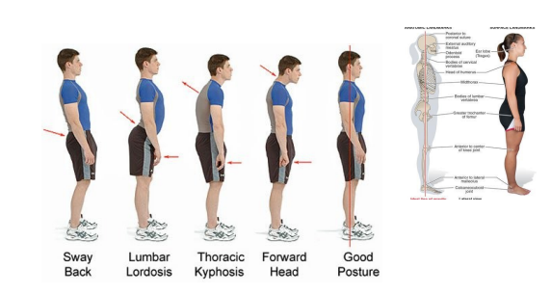

Anatomical Position and Directional Terms
- Anterior – Front
- Posterior – Back
- Superior – Above
- Inferior – Below
- Proximal – Closer to the point of origin
- Distal – Farther from the point of origin
- Ipsilateral – Same side
- Contralateral – Opposite side
- Medial – Toward the midline
- Lateral – Away from the midline
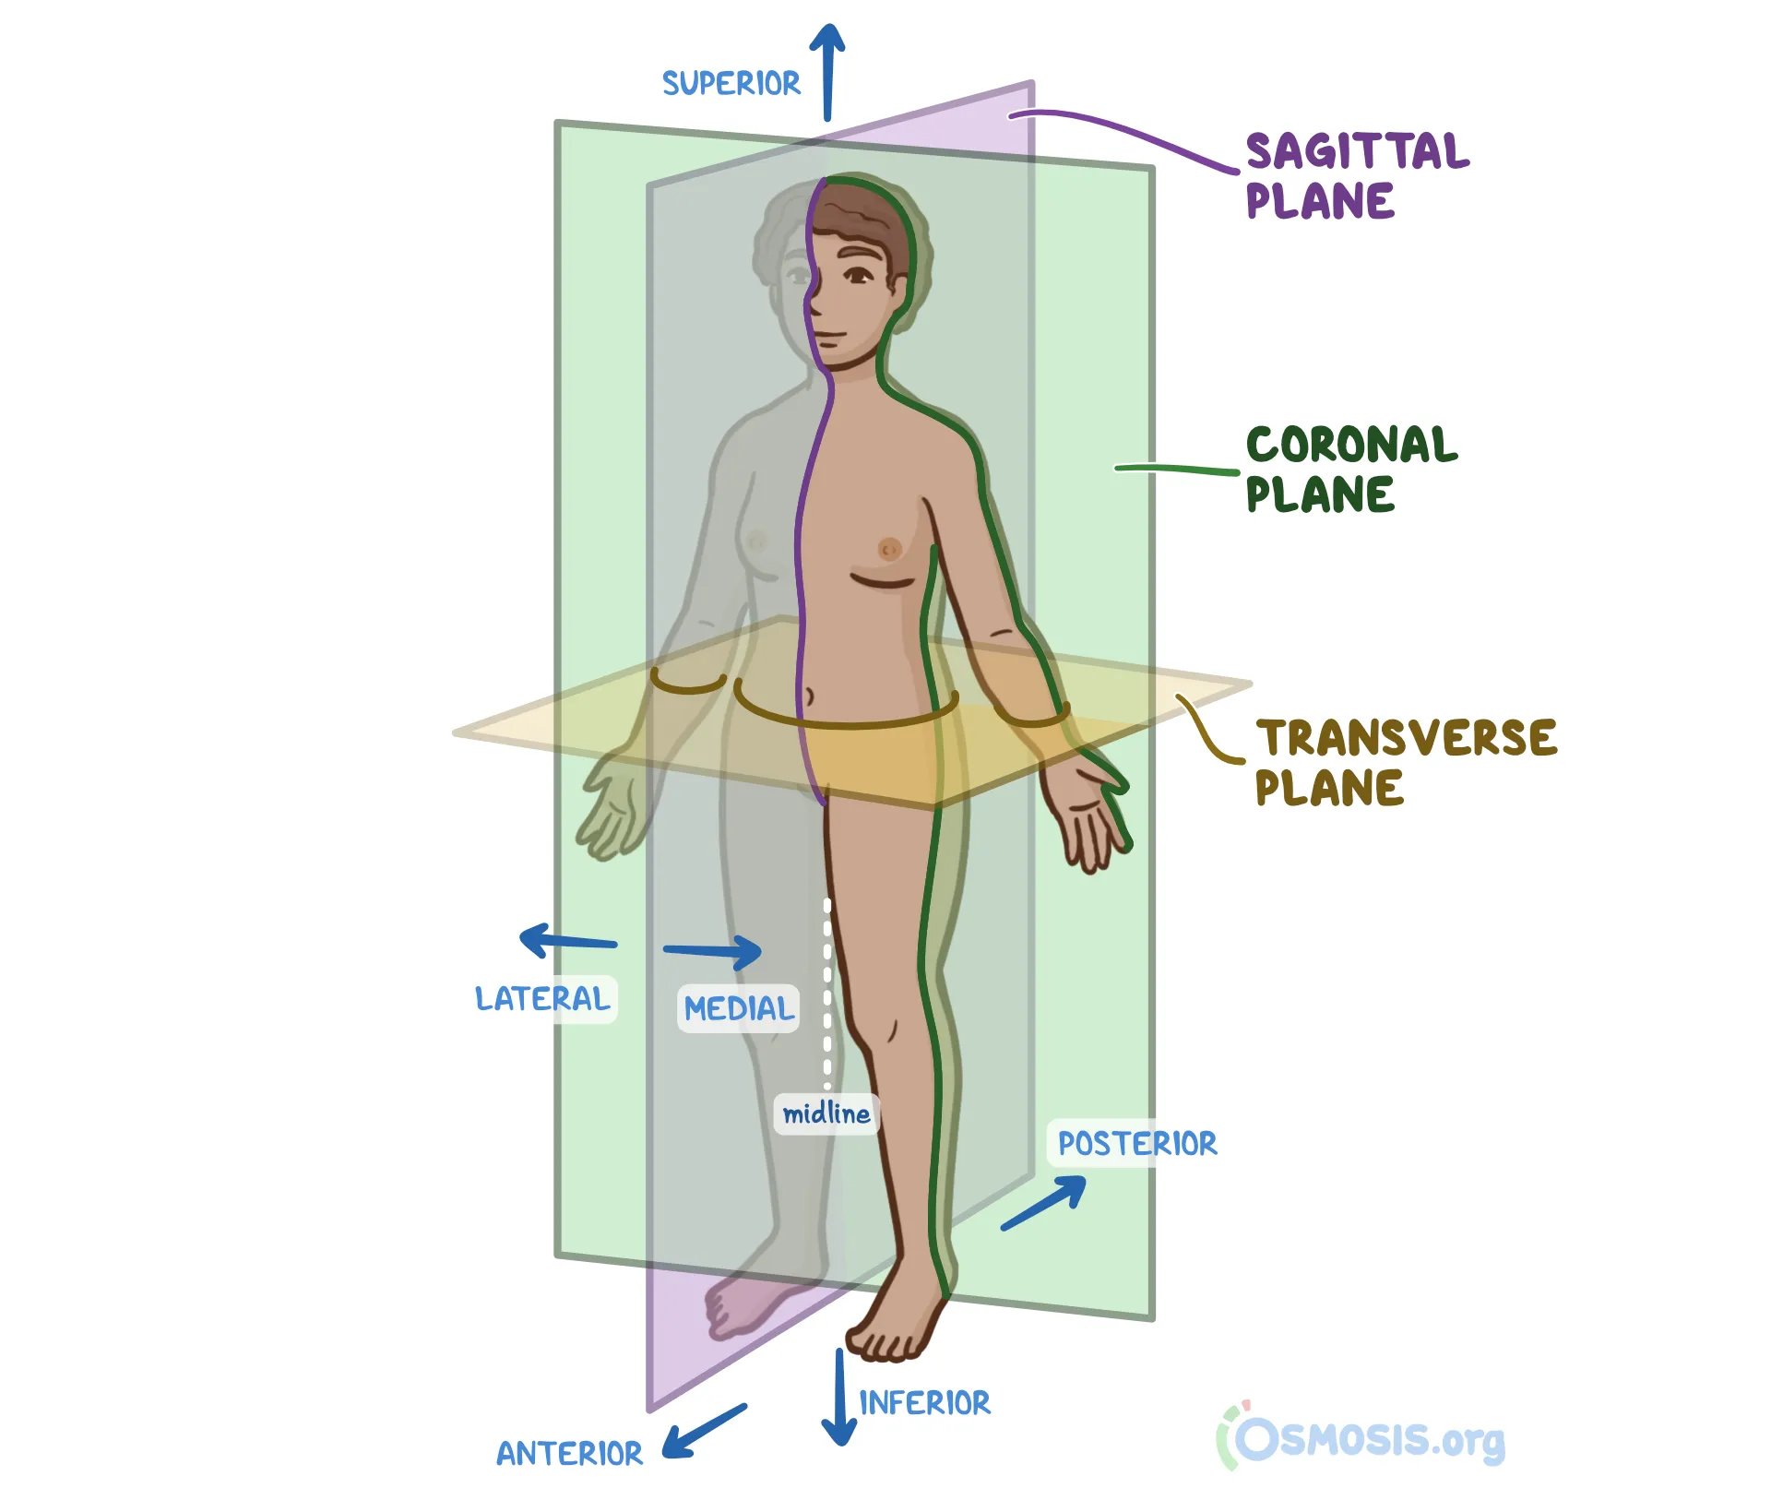
Three Planes of Motion
- Frontal Plane (XY Plane)
  - Divides the body into front and back.
  - Movement: side-to-side (e.g., jumping jacks)
- Sagittal Plane (YZ Plane)
  - Divides the body into left and right.
  - Movement: forward and backward (e.g., squats, walking)
- Horizontal Plane (Transverse Plane)
  - Divides the body into top and bottom.
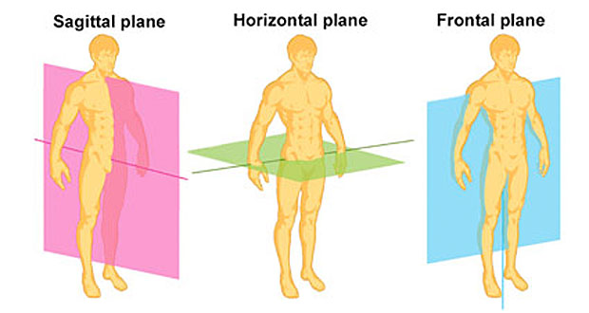
  - Movement: rotation (e.g., twisting your torso)

Anatomical Movements of the Body
- Flexion – Bending a joint (e.g., elbow bend)
- Extension – Straightening a joint
- Abduction – Movement away from midline
- Adduction – Movement toward midline
- Elevation – Raising a body part (e.g., shrugging)
- Depression – Lowering a body part
- Pronation – Palm facing downward
- Supination – Palm facing upward
- Dorsiflexion – Toes move upward
- Plantarflexion – Toes point downward

Functional Anotomy of the Core

The core is the center of our body and it functions to stabilize the trunk and spine during functional movements.

Functions of the Core

Stabilizes the thorax, spine, and pelvis
- Keeps the spine, ribs, and pelvis aligned during movement and rest
- Supports posture and protects the lower back
- Assists with breathing
- Supports internal organs
Stabilizers
It provides trunk stiffness and control movements within a joint such as when the vertebral segments bend, slide or rotate. These muscles include the transversus abdominis (TVA), internal oblique, diaphragm.
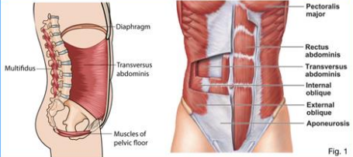

Mobilizers
- are superficial layers of the core trunk muscles that enable trunk flexion, extension and rotation.
- Rectus Abdominis- appears to be the strongest trunk flexor and is the most active during sit-ups and curl-ups.
- External Oblique - Abdominal Muscles generally produce trunk rotation such as when you swing a baseball bat or golf club.
- Erector Spinae- functions mainly to produce extension and rotation of the spine.

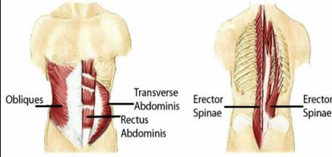

Other Key Core Structures

- Diaphragm – Separates the chest and abdominal cavity; helps in breathing
- Pelvic Floor – Made of four muscles that hold pelvic organs in place
- Multifidus – Deep spine stabilizer running the full length of the back
- Quadratus Lumborum (QL) – Helps bend the spine sideways; active in side crunches
- Thoracolumbar Fascia – Large membrane in the lower back
  - Connects upper and lower body
  - Serves as an anchor for many core muscles

